Which are ratios are in proportion (which are equivalent ratios)
a 4 : 2 and 6 : 3 b 2.0 : 0.5 and 8 : 2 c 2.5 : 0.5 and 10 : 2

d 20 mins to 1 hour and 30 mins to 1 hour 30 mins

e 2 tonnes are loaded in 3 hours and 6 tonnes are loaded in 9 hours.

f Travel 100 km on 8 litres of petrol and travel 200 km on 16 litres of petrol.

-

Direct Proportion
1 If $AU1 can be exchanged for $US1.06, how many Australian dollars
can be exchanged for $US1280?

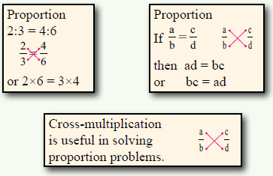
2 A car uses 6.8 litres of petrol to travel 100 km.
How far will the car travel on 52 litres of petrol?

3 100 g contains 2.3 g of fat.
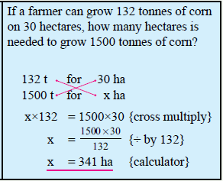
How much fat in 250 g?

4 The concrete requires a mix of 6 bags of sand to one bag of cement.
How many bags of cement need to be mixed 35 bags of sand?

Draw a graph and find the rule for each of these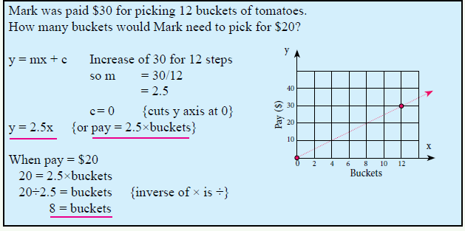

Use a Graph and write a rule to solve these
1 Aaron can run 4 km in 20 minutes.
How far can Aaron be expected to run in 1.5 hours?

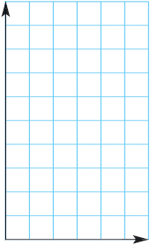

2 Megan can run 3 km in 14 minutes.
How long would it take Megan to run 10 km?


-

3 The infusion pump was set to give 300 mL of medication over 120 minutes.
How much medication would be given in 15 minutes?
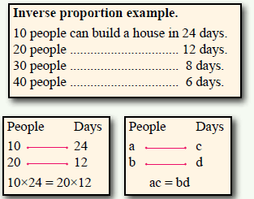


Inverse Proportion
1 Travelling from A to B will take 30 mins at an average speed of 80 km/h.
How long will it take at an average speed of 100 km/h?

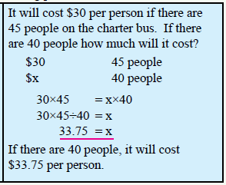
2 Travelling from A to B will take 30 mins at an average speed of 80 km/h.
What average speed would be needed to reduce the time to 20 mins?

3 If it takes 24 hours for a hose with a water flow of 15 litres per minute to
fill a tank, how long will it take to fill the tank if the water flow is
increased to 20 litres per minute?

Proportion and Money Questions
Q1 1.55 square metres of cloth cost $8.35.
a) What is the cost of 4.8 square metres of cloth?

b) How much cloth for $20?

Q2 If $NZ3610 can be exchanged for JPY238 937 (Japanese Yen).
- How many New Zealand Dollars can be exchanged for JPY1000?

b) How many Japanese Yen can be exchanged for $NZ1000?

Q3 1000 size 23/15 staples cost $12.78.
a) How many staples for $100?

b) What is the cost of 5000 staples?

